Curriculum Vitae
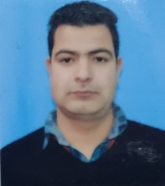

Shakir Majeed Wagay
Address: Dooru Mirmaidan Anantnag-192212J&K
Contact No:7006426987
Email : Emolicfaisu123@gmail.com

Objectives:
 ➢ To serve the organization as a hard-worker in this competitive
environment discharging all my professional skills.
 ➢ I am looking for good career growth opportunities where my talent and
knowledge could be best subjected and utilized for the benefit of the
organization and myself.

Professional Qualification:
 ➢ B-A in English ignou
 ➢ Diploma in computer

Academic Qualification:
 ➢ 12th IGNOU J&K (U.T)
 ➢ 10th J&K Board of School Education, J&K (U.T)

Experience:
7 YEARS

Strength:
 ➢ Ability to work underpressure and accepting challenging
assignments.
 ➢ Ability to prioritize and can be effective in time management.
 ➢ Good Communication skills, Team Player and highly motivated.

Personal Details:
Father’s Name : Abdul Majeed wagay
Permanent Address : Doru Mirmaidan Distt. Anantnag
Date of Birth : 01-03-1997
Language Know : English, Urdu, Kashmiri.
Hobbies : Reading Books , Gardning
Marital Status : Unmarried
Nationality :Indian

Declaration:
I, Shakir Majeed Wagay hereby declare that all the details furnished above are true to the best of my knowledge.

Place:
Date : Shakir Majeed Wagay

