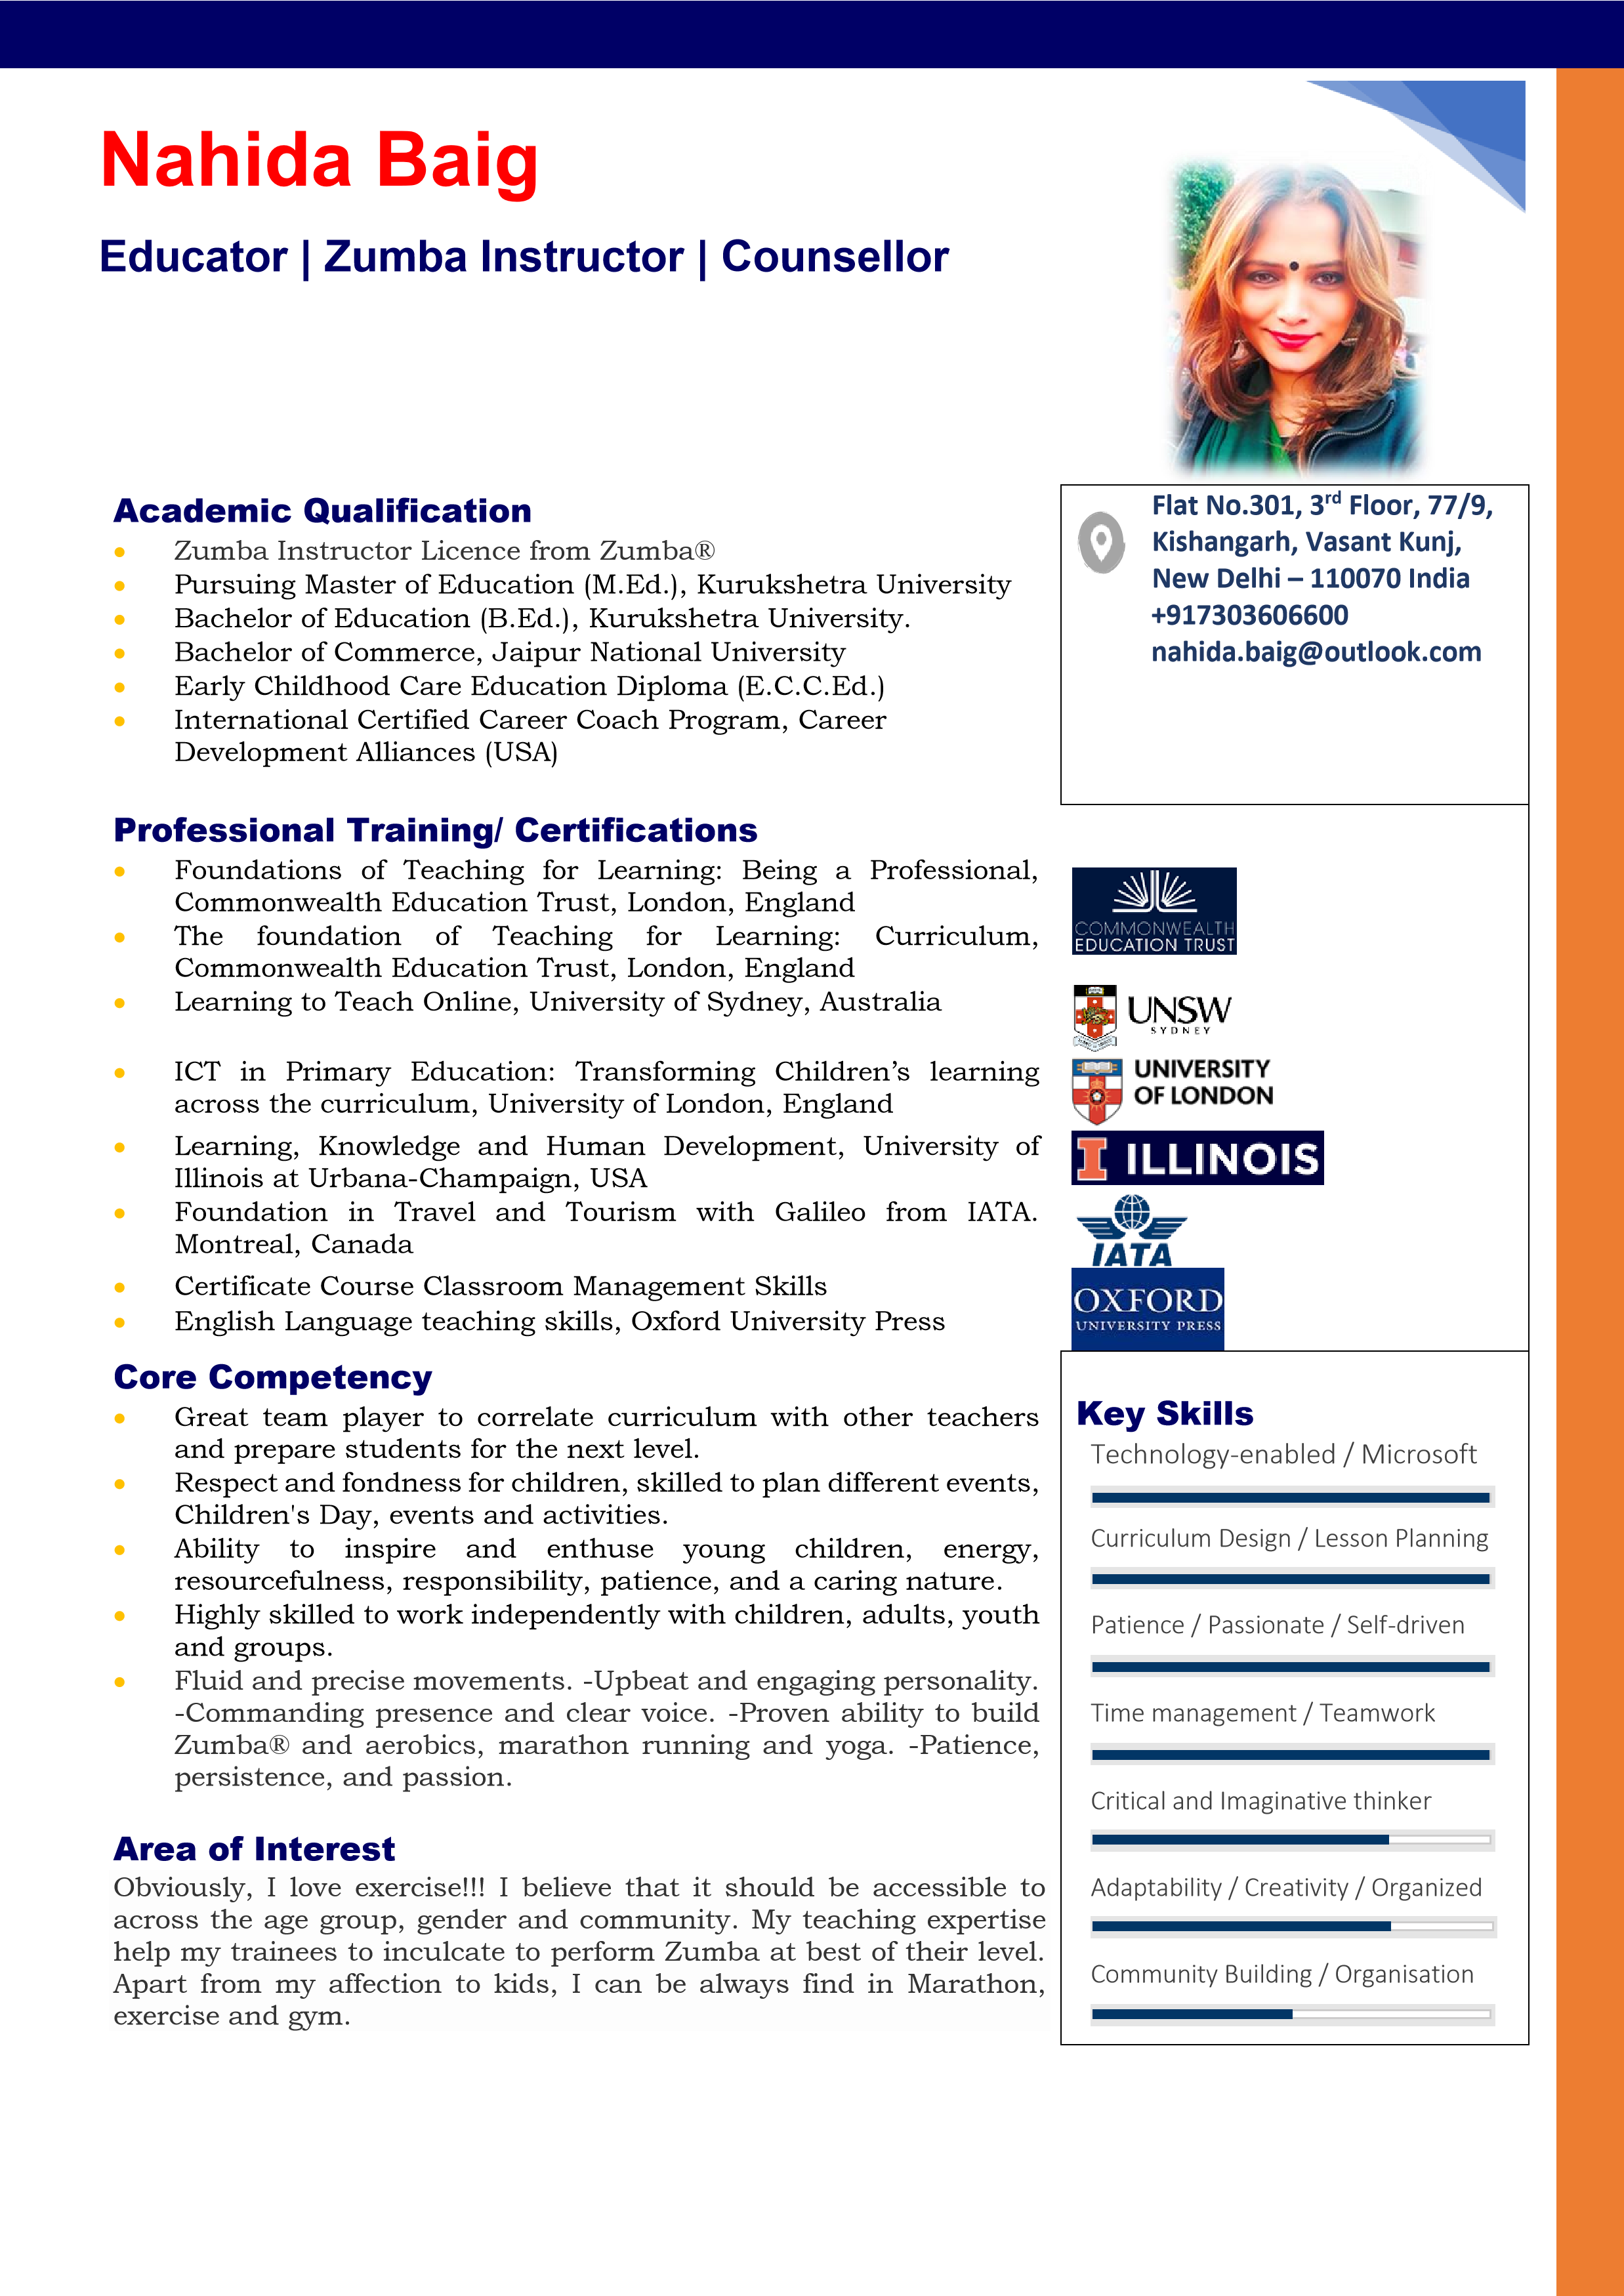
- Taught children the fundamental skills of math, science, ICT, and language through various methods of teaching. Responsible to conduct extracurricular activities for the students.
- Created lesson plans that cover all subjects on a daily, weekly, and monthly basis. Incorporated learning into all activities even plays a tile.
- Prepared students for various activities. (Annual Day, Grand Parents Day, Sports Day, Annual Fete)
- Maintained a safe and healthy environment for children - Held responsibility for child safety while in school premises. Promoted activities which encouraged children to develop new ideas • Lead Zumba® gym classes geared toward beginners and active senior citizens.

Skill and Competency

Educator | Zumba Trainer | Councellor

- Combine Zumba® core rhythms (Merengue, Salsa, Cumbia, and Reggaeton) with approved dance and choreography.
- Enhance students’ overall levels of muscular conditioning, balance, flexibility, and cardiovascular health. Design workouts to meet students’ needs (older adults versus younger adults).
- Earn high satisfaction scores, and use passion and enthusiasm to infuse a love of fitness among students.
- Started with teaching two classes a week; demand and skill currently able to teach five weekly.
- Taught a variety of group fitness classes to multiple populations (ex: aerobics to kids, swimming to senior citizens). Developed lesson plans to maximize students’ chances of success.
- Identified a general goal for each class to give focus and to set expectations (ex: to improve flexibility, to lose weight, to simply get moving more).

Experience
- My Edubag- IDeserve Education private Limited Currently working
- Modern School, Vasant Vihar, Delhi, India August 2018-June 2020
- Indian School Muscat, Muscat, Oman August 2016-April 2018
- Sarti International School, Gwalior, MP, India April 2013-July 2016
- Shantiniketan Public School & Jr. College, Bombay, India Aug 2011- March 2013
- Euro Kids, New Panvel branch, Bombay Sept 2010 - July 2011
- Nummer Eins Services, Bombay, India Dec 2003 - Feb 2006
- Page point Services Pvt. Ltd. Bombay, India March 2004 - Dec 2004

References
Swati Roy Gyanendra Tewatia
Principal Vice President
Shantiniketan Public School Fitso by Zomato
New Panvel, Raigad, Mumbai, India Email: igyan@outlook.com
Email: principalshantiniketan@gmail.com +919958628767
Mobile: +91- 9987024436, +917498018331

Mr.Piyush Vaishnava
Principal
Podar International School, MP, India
Email: pv917@hotmail.com
9977002825, 8077838990, 8291200891

